**Lesson 3 – Problem Solving and SWOT Analysis**

**Agenda:**

* Problem and effective problem solver
* Problem tree
* Solution tree
* Logical reasoning – SWOT Analysis

**Problem and effective problem solver**

**Problem** is a matter or situation regarded as unwelcome or harmful and needing to be dealt with and overcome.

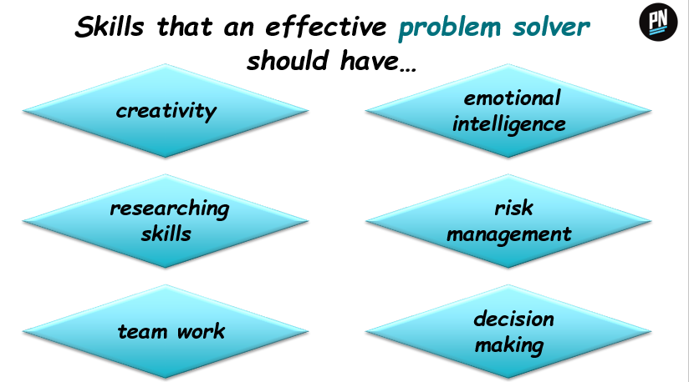

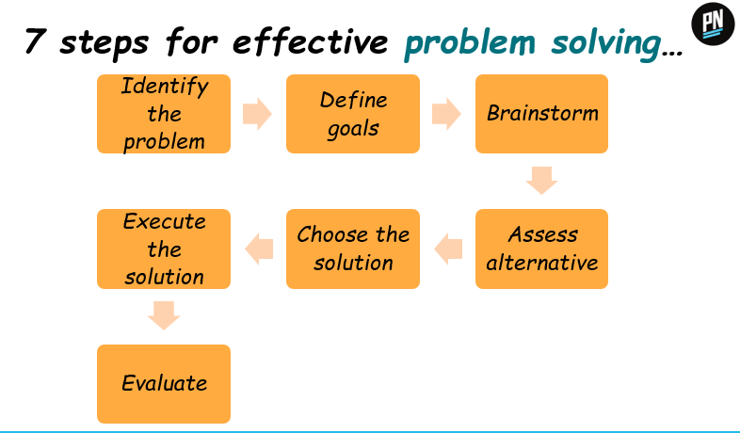

**Problem tree**

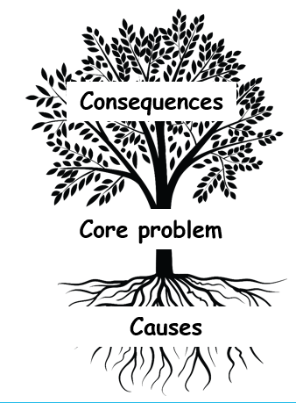**Problem tree** is a method of mapping out core problems, along with their causes and effects, helping project planners to identify clear and manageable objectives.

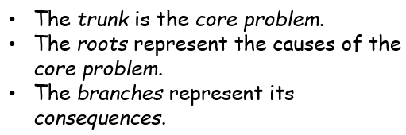

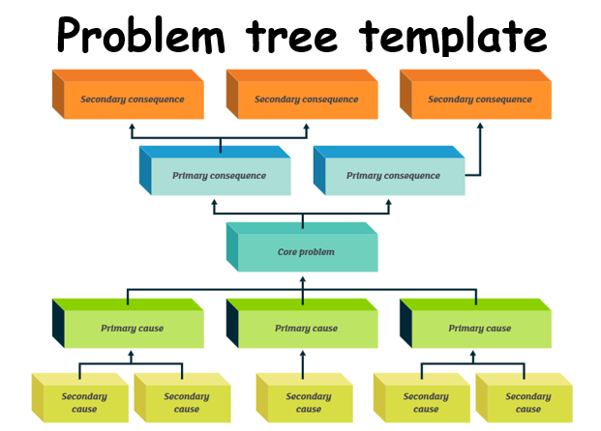

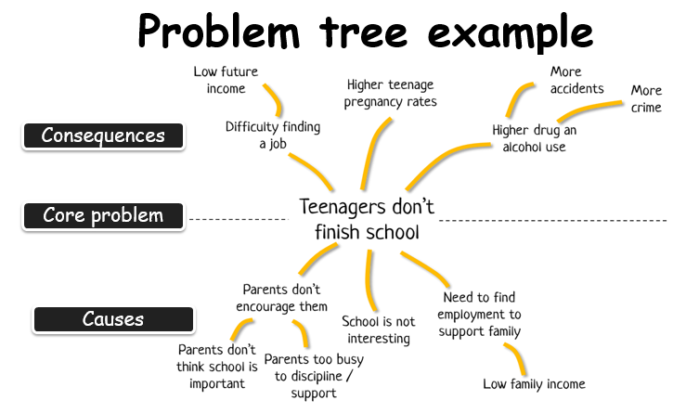

**Usefulness of the problem tree…**

* Provide in-depth information on the problem
* Help closely examine the problem by dissecting it into manageable pieces
* Help in developing a multi-pronged strategy to deal with the different aspects of the problem
* Ensure that every aspect of the problem is taken into consideration

**Solution tree**

A **solution tree** outlines the initiatives, actions and projects which develop as logical solutions from the initial problem tree.

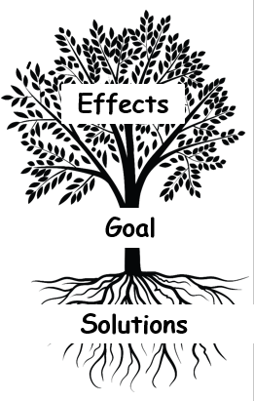

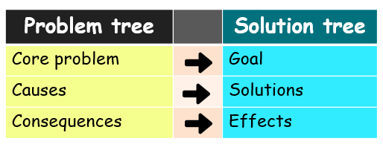

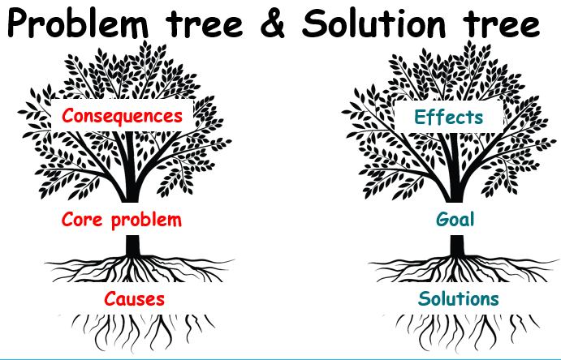

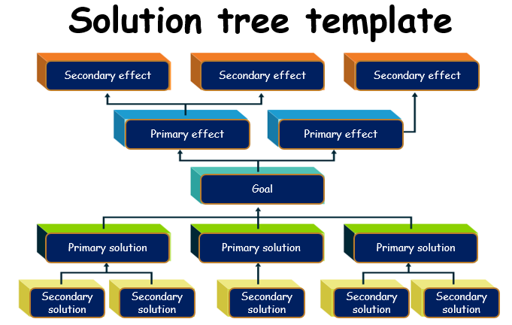

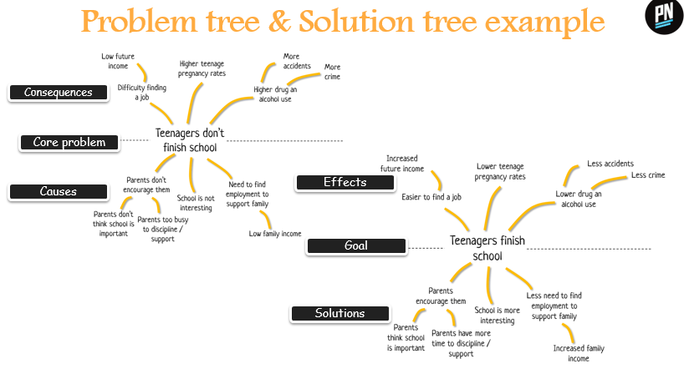

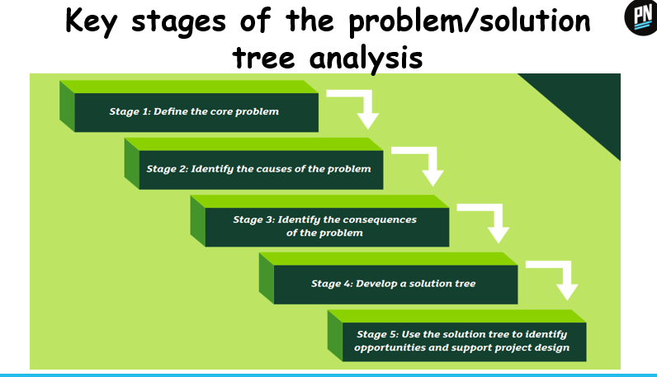

**SWOT Analysis**

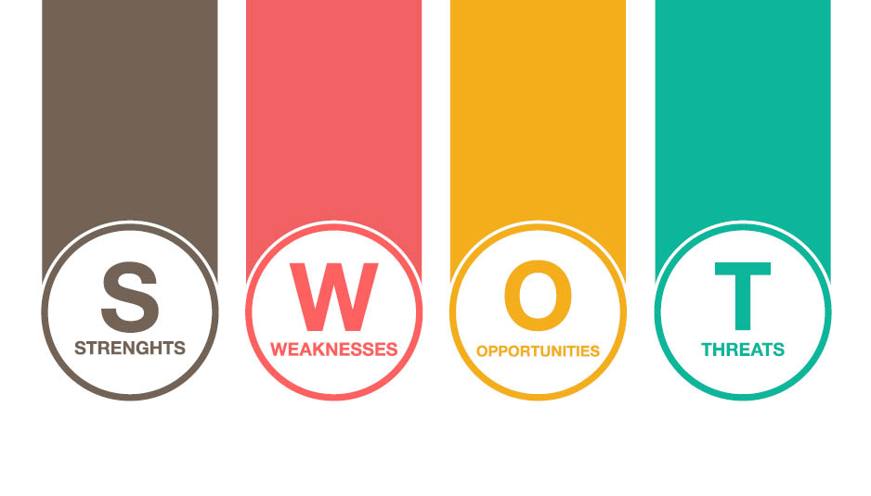

**A SWOT** can help you better understand how to play to your strengths and manage your weaknesses, as well as uncover opportunities for growth and eliminate threats that could keep you from moving forward.

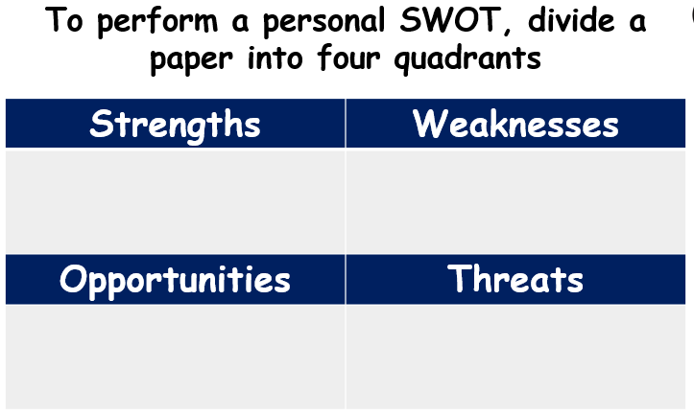

**Strengths** are the characteristics that give it an advantage over others.

**Questions to discover your strengths**

* How do your education, skills, talents, certifications, and connections set you apart from your peers?
* What would your boss or co-workers say are your strengths?
* What values or ethics do you have that your peers often lack?
* What achievements are you most proud of?

**Examples of personal strengths**

* Enthusiasm, Trustworthiness, Creativity, Discipline, Knowledge & skills, Patience, Respectfulness, Determination, Dedication, Honesty

**Weaknesses** are characteristics that place a person, a business, or project at a disadvantage relative to others.

**Questions to discover your weaknesses**

* Where are your education, training, or skills lacking?
* What would your boss or co-workers say are your weaknesses?
* What are your negative work habits and personality traits?
* What do you avoid because you lack confidence?

**Examples of personal *weaknesses***

* Easily distracted
* Not a fast learner
* Easily get nervous
* Not always confident
* Take time to understand new concepts
* Shy and not comfortable when talk to people

**Opportunities** are elements that a person, business, or project could exploit to its advantage.

**Questions to discover your *opportunities***

* What trends are affecting your industry?
* In what areas is your industry growing?
* How could new technology help you advance?
* How could your connections help you?

**Examples of personal *opportunities***

* A specific job opening
* Use of a new technology
* An upcoming company project
* Receive coaching in service of improving skills
* Enhance ability to manage the need to complete task quickly

**Threats** are elements in the environment that could cause trouble for the business or project.

**Questions to discover your *threats***

* What obstacles do you currently face in your career?
* Who is your competitor?
* Will new technology or certification demands slow your progress?
* How is your job or industry changing in ways that could affect your advancement?

**Examples of personal *threats***

* Changing market requirements and their impact on you
* Changing professional standards that you don't meet
* Reducing demand for one of your skills
* Evolving technologies you're unprepared for
* A company decision maker does not like or support you